ASSIGNMENT NO.10: Window Functions and Analytical Queries

Student Name | Aditya Ballal | Roll Number | 20966
Batch | SY. BSc Data Science | Topic | WB(Assignment-10)

Questions
Q1) Create a MySQL database named SalesDB and a table named SalesData. SalesData Table
Column Name | Data Type | Constraint
SaleID | INT | PRIMARY KEY
Salesperson | VARCHAR(50) | NOT NULL
Department | VARCHAR(30) | NOT NULL
SaleDate | DATE | NOT NULL
Amount | DECIMAL(10,2) | NOT NULL

Insert at least 12 sales records belonging to three different departments.
Query:
CREATE DATABASE SalesDB;
USE SalesDB;

CREATE TABLE SalesData (
SaleID INT PRIMARY KEY,
Salesperson VARCHAR(50) NOT NULL,
Department VARCHAR(30) NOT NULL,
SaleDate DATE NOT NULL,
Amount DECIMAL(10,2) NOT NULL
);

INSERT INTO SalesData (SaleID, Salesperson, Department, SaleDate, Amount) VALUES
(1, 'Aarav Shah', 'Electronics', '2026-01-05', 50000.00),
(2, 'Priya Patil', 'Furniture', '2026-01-08', 40000.00),
(3, 'Rohan Desai', 'Electronics', '2026-01-12', 65000.00),
(4, 'Sneha Joshi', 'Furniture', '2026-01-15', 55000.00),
(5, 'Karan Mehta', 'Electronics', '2026-02-05', 65000.00),
(6, 'Meera Kulkarni', 'Furniture', '2026-02-10', 30000.00),
(7, 'Neha Shah', 'Clothing', '2026-02-12', 45000.00),
(8, 'Aman Verma', 'Clothing', '2026-02-18', 45000.00),
(9, 'Divya More', 'Electronics', '2026-03-03', 80000.00),
(10, 'Rahul Sharma', 'Furniture', '2026-03-06', 60000.00),
(11, 'Isha Nair', 'Clothing', '2026-03-10', 70000.00),
(12, 'Om Jadhav', 'Electronics', '2026-03-14', 55000.00);
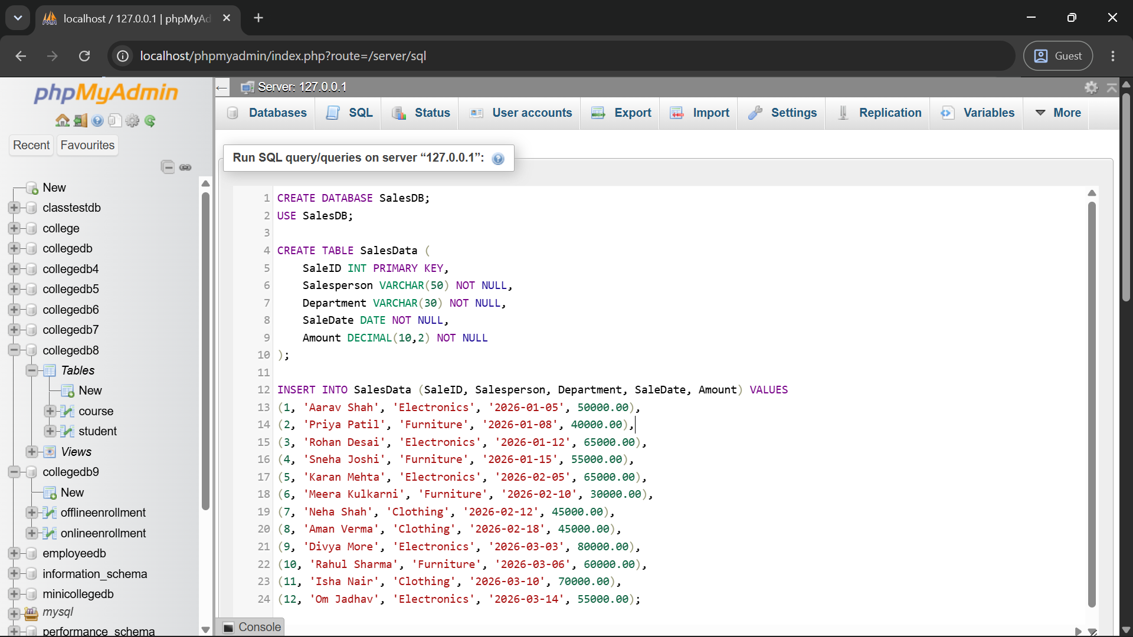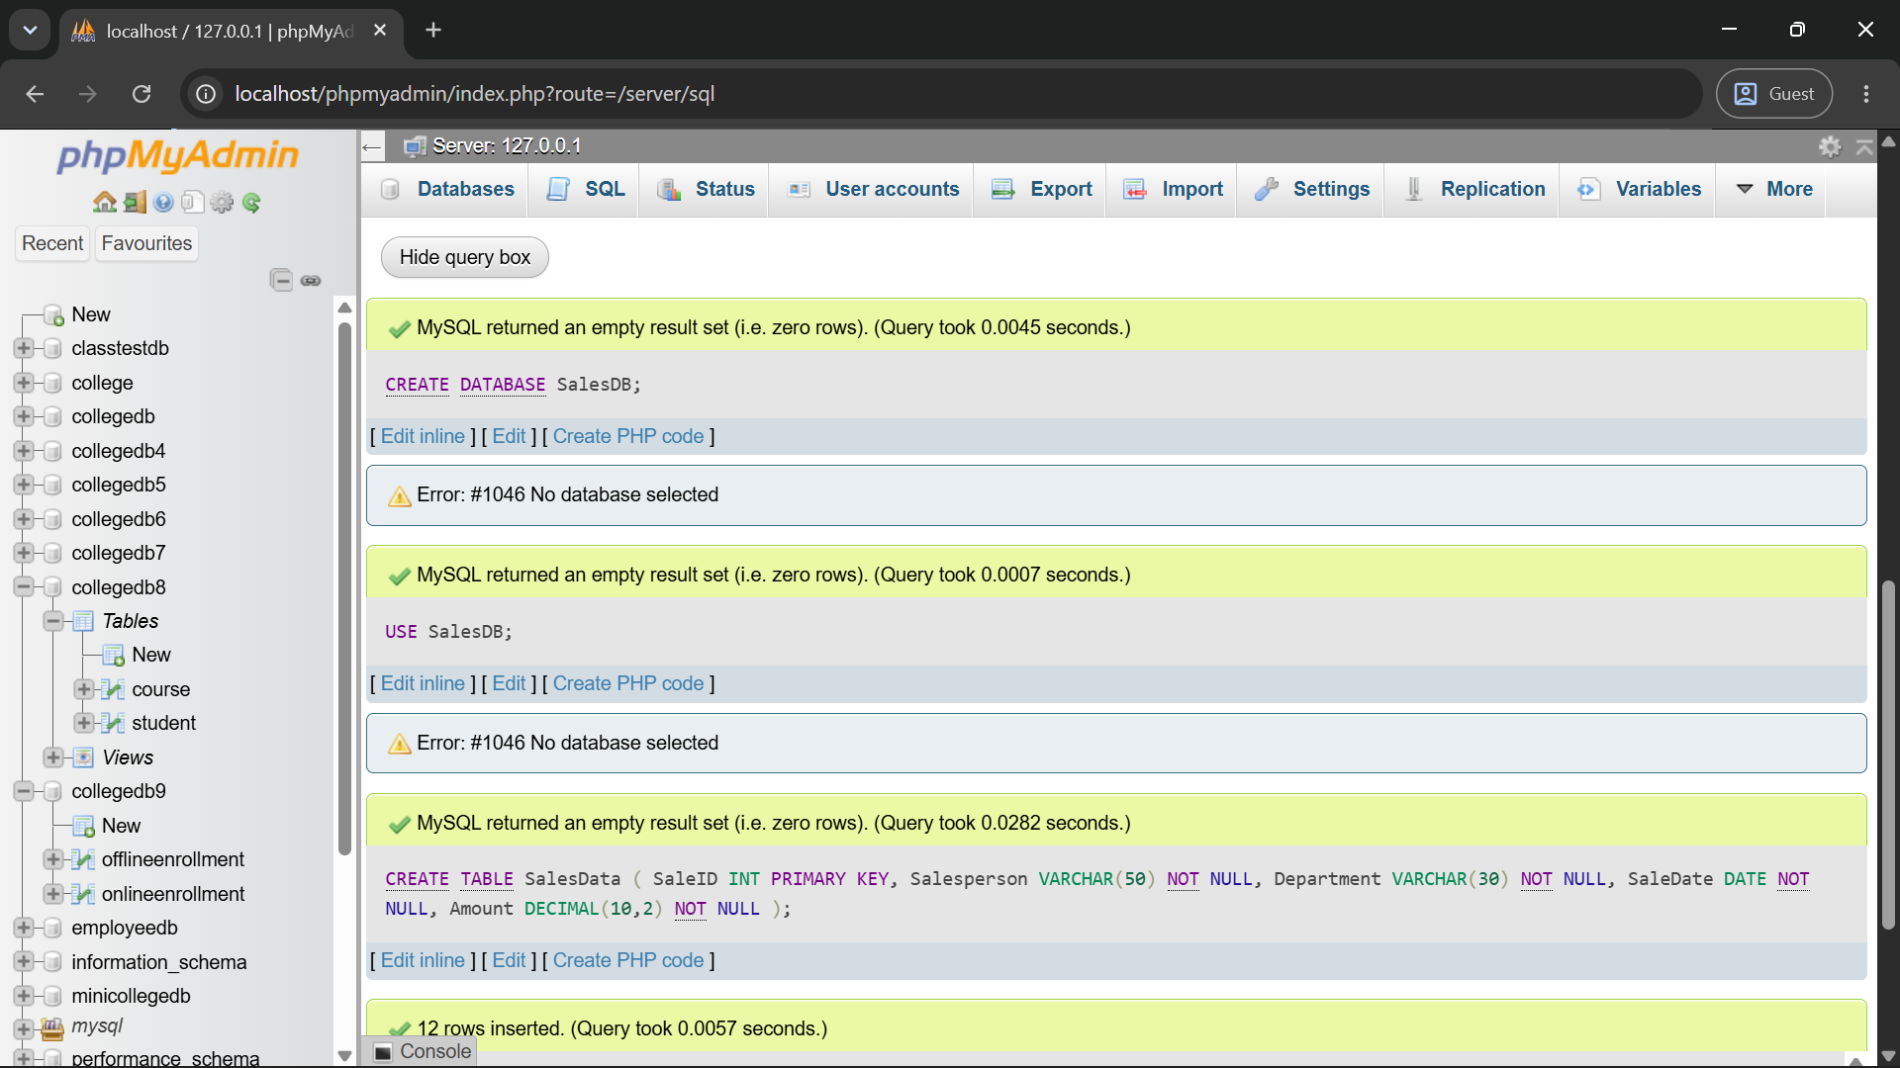
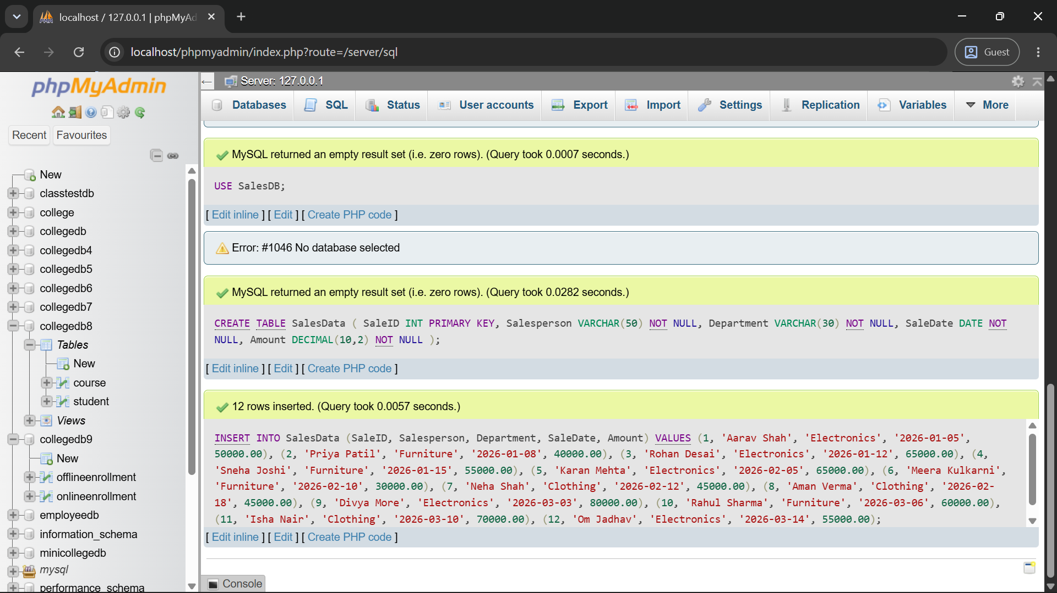

Q2) Write a MySQL query using ROW_NUMBER() to assign a unique row number to every salesperson.
The result should be arranged by sale amount from highest to lowest.
Required Output
Column
Salesperson
Department
Amount
SalesRowNumber
Query:
SELECT
Salesperson,
Department,
Amount,
ROW_NUMBER() OVER (ORDER BY Amount DESC) AS SalesRowNumber
FROM SalesData;
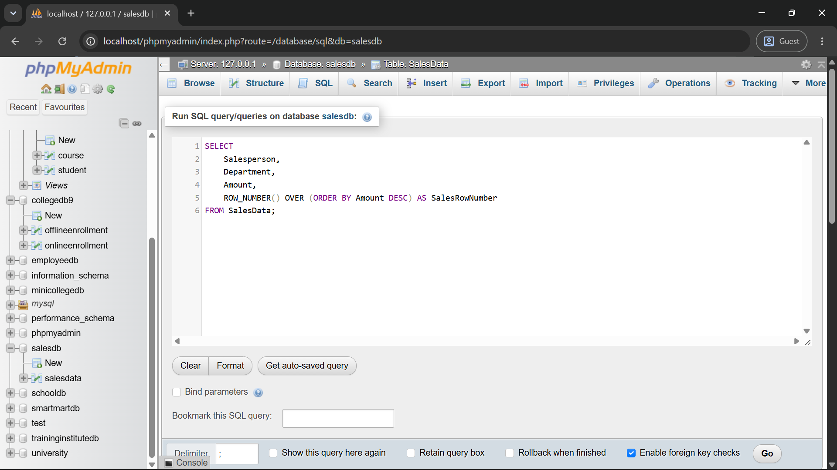
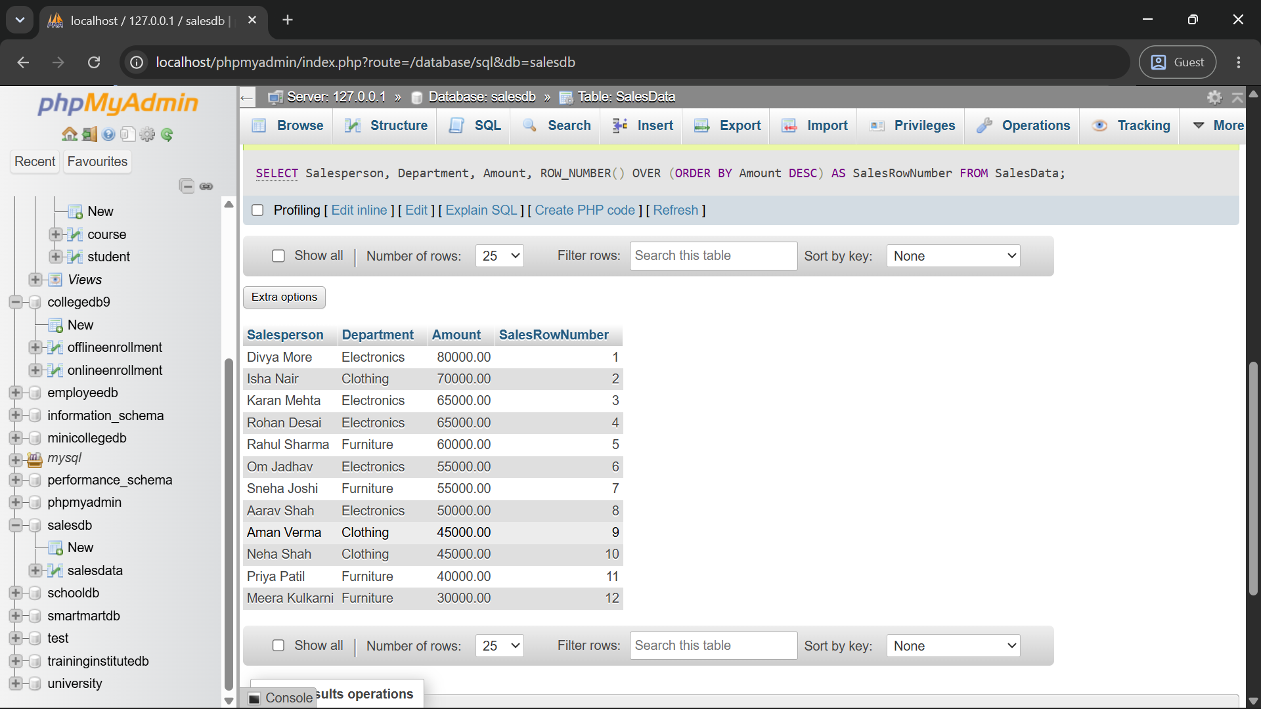
Q3) Write a MySQL query using RANK() to rank salespersons according to their sale amount.
Students having the same sale amount should receive the same rank.
Required Output
Column
Salesperson
Department
Amount
SalesRank
Query:
SELECT
Salesperson,
Department,
Amount,
RANK() OVER (ORDER BY Amount DESC) AS SalesRank
FROM SalesData;
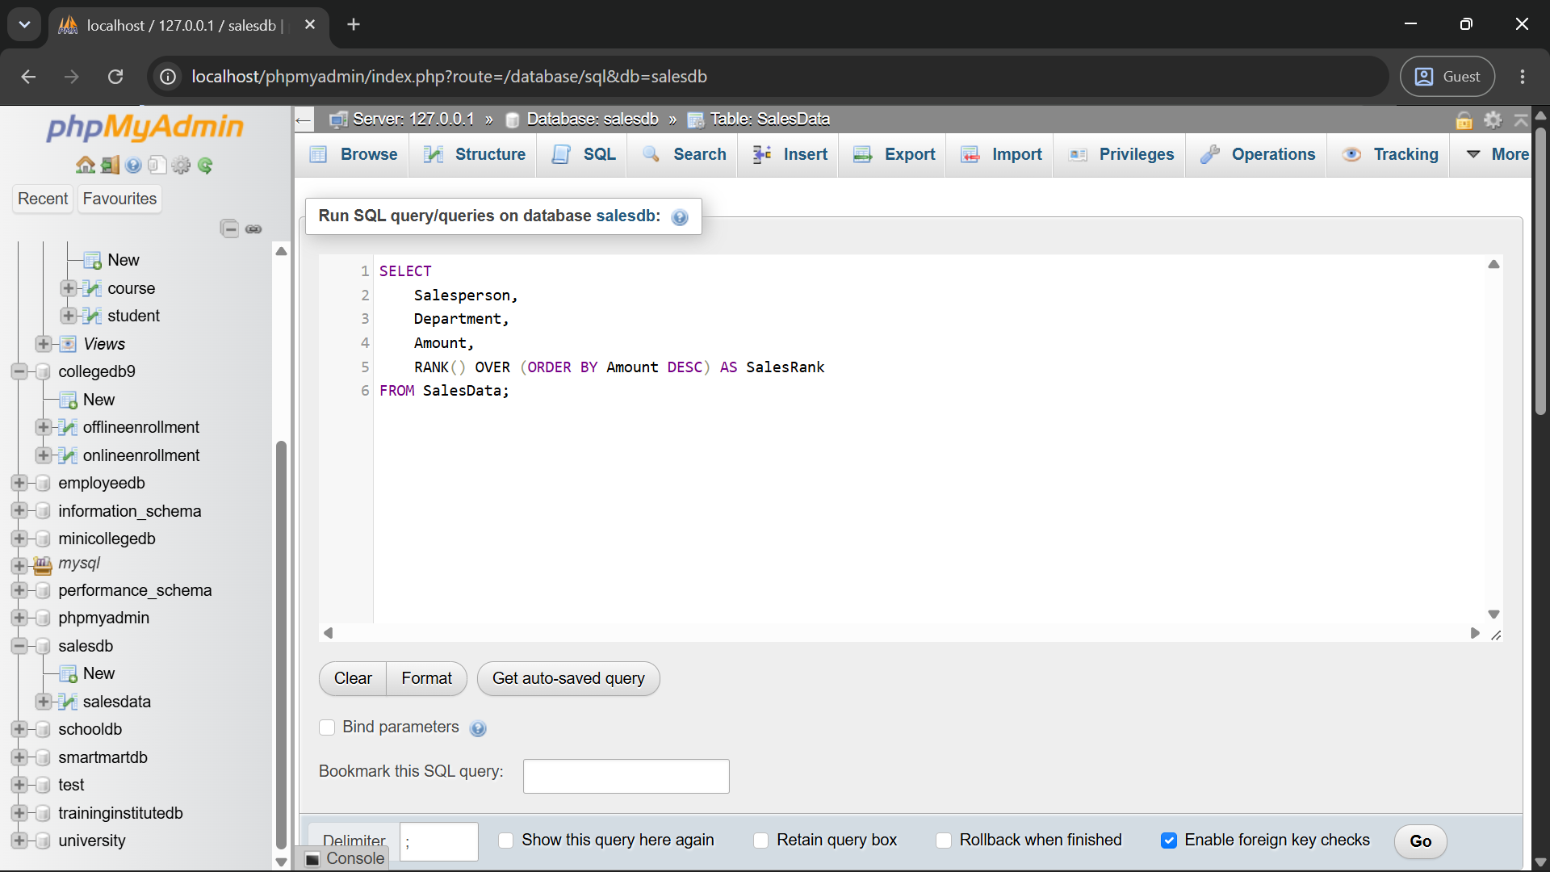
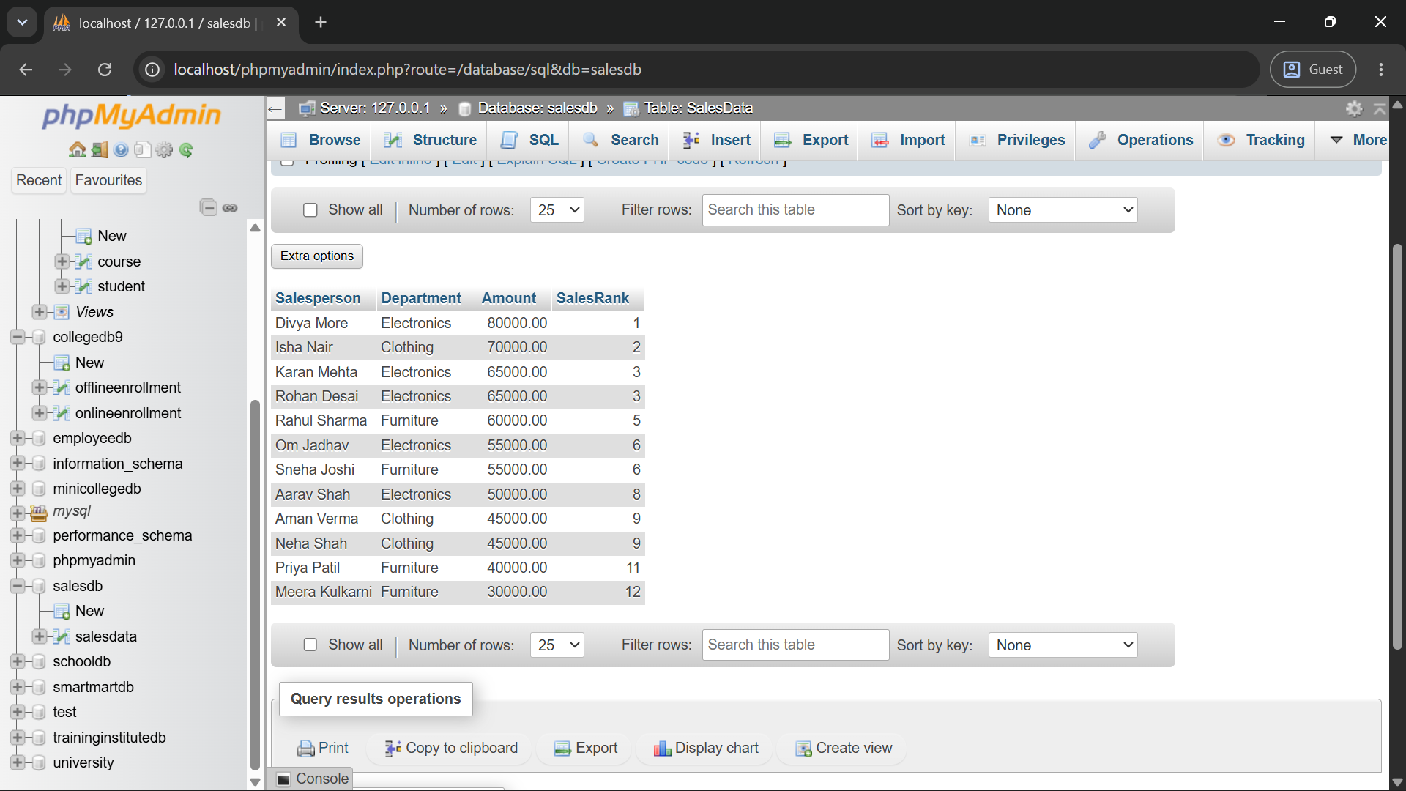

Q4) Write a MySQL query to rank salespersons separately within each department.
Use:
Required Component
RANK()
OVER
PARTITION BY Department
ORDER BY Amount DESC
Query:
SELECT
Salesperson,
Department,
Amount,
RANK() OVER (PARTITION BY Department ORDER BY Amount DESC) AS DepartmentRank
FROM SalesData;
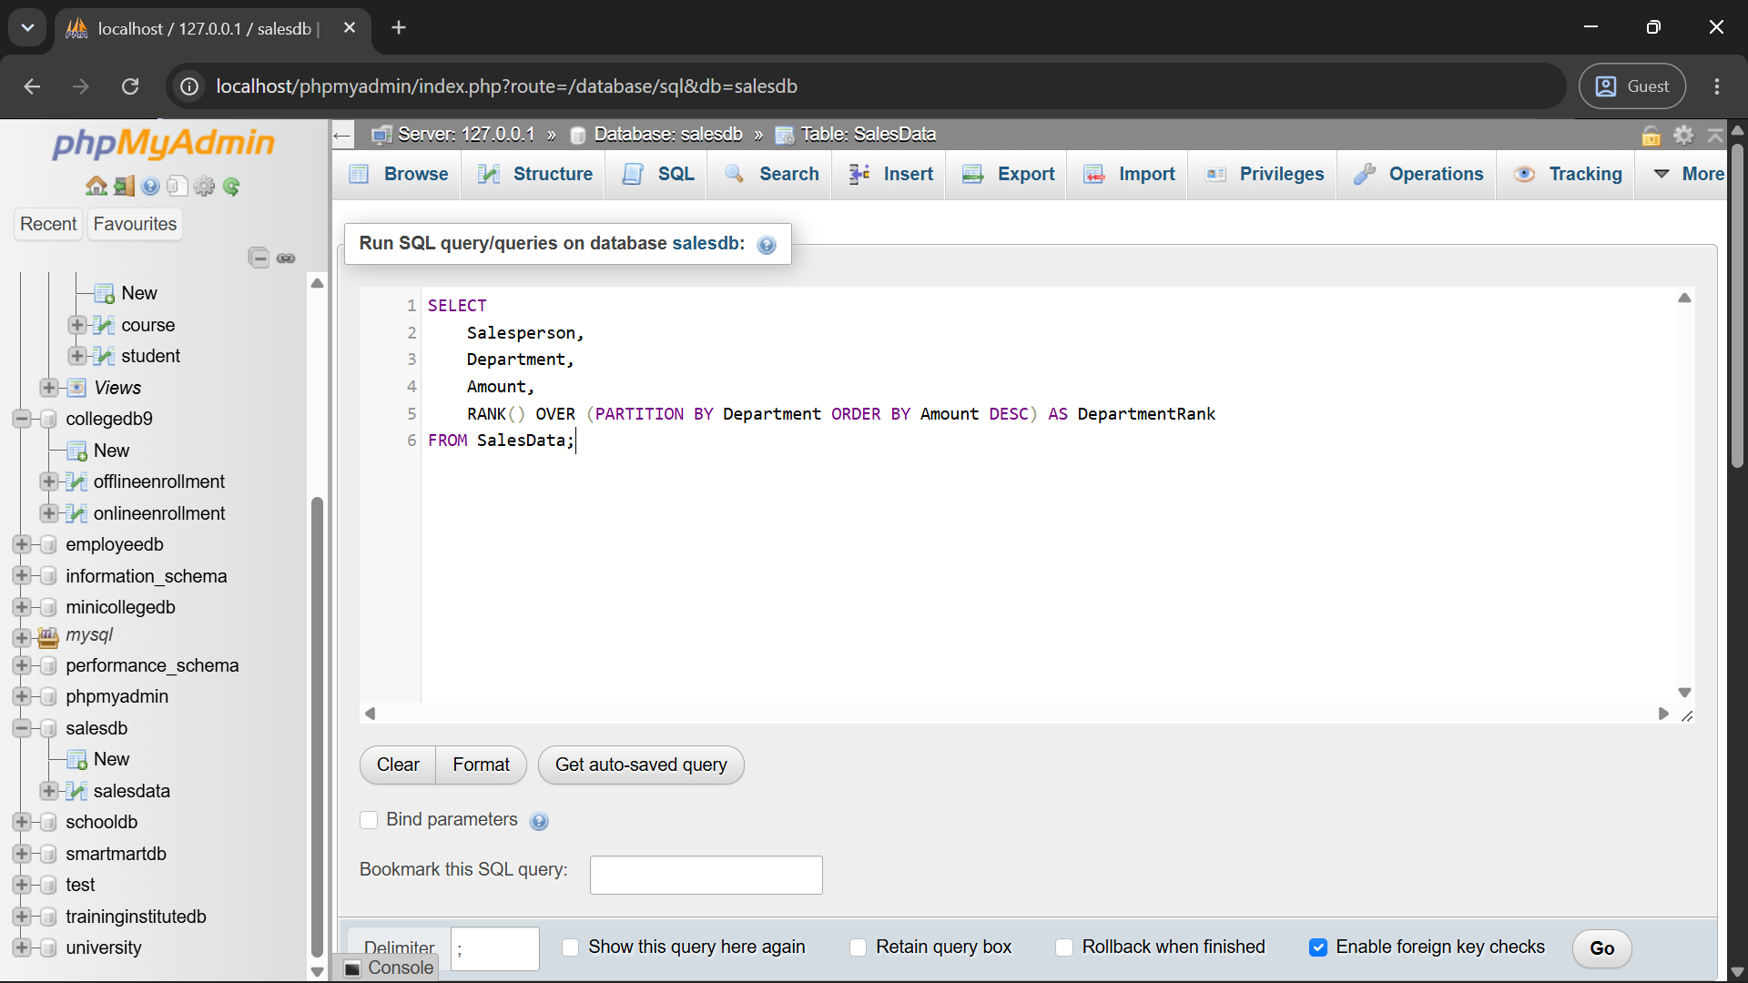
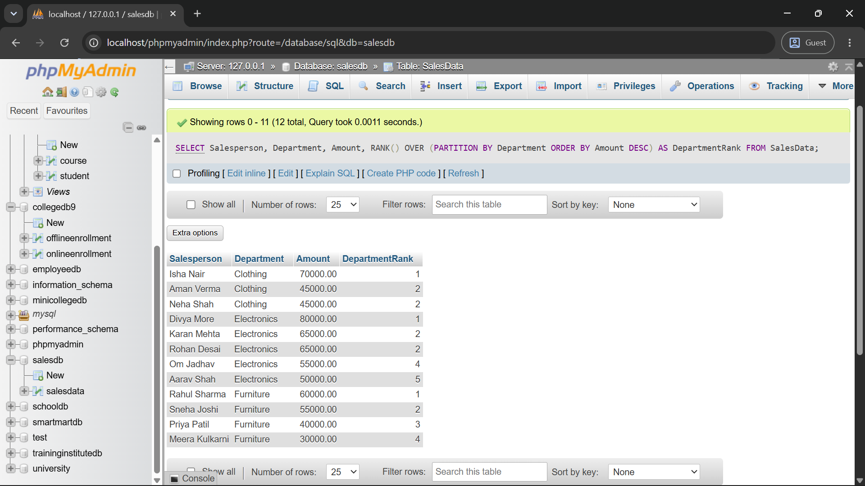
Q5) Write a MySQL query to calculate the running total of sales according to the sale date.
Required Output
Column
SaleID
Salesperson
SaleDate
Amount
RunningTotal
Query:
SELECT
SaleID,
Salesperson,
SaleDate,
Amount,
SUM(Amount) OVER (ORDER BY SaleDate, SaleID ROWS BETWEEN UNBOUNDED PRECEDING AND CURRENT ROW) AS RunningTotal
FROM SalesData; 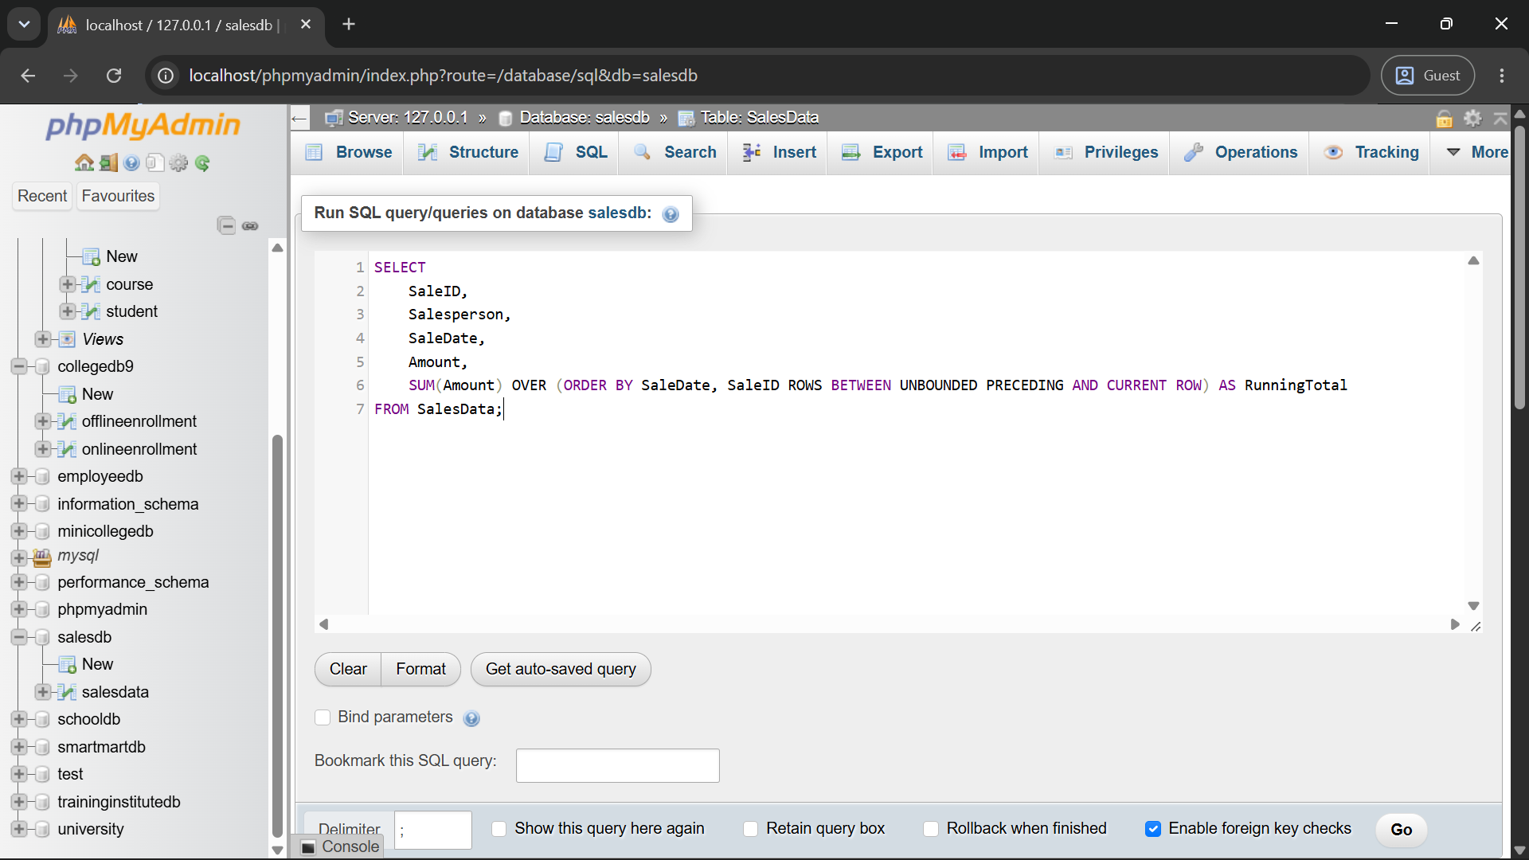
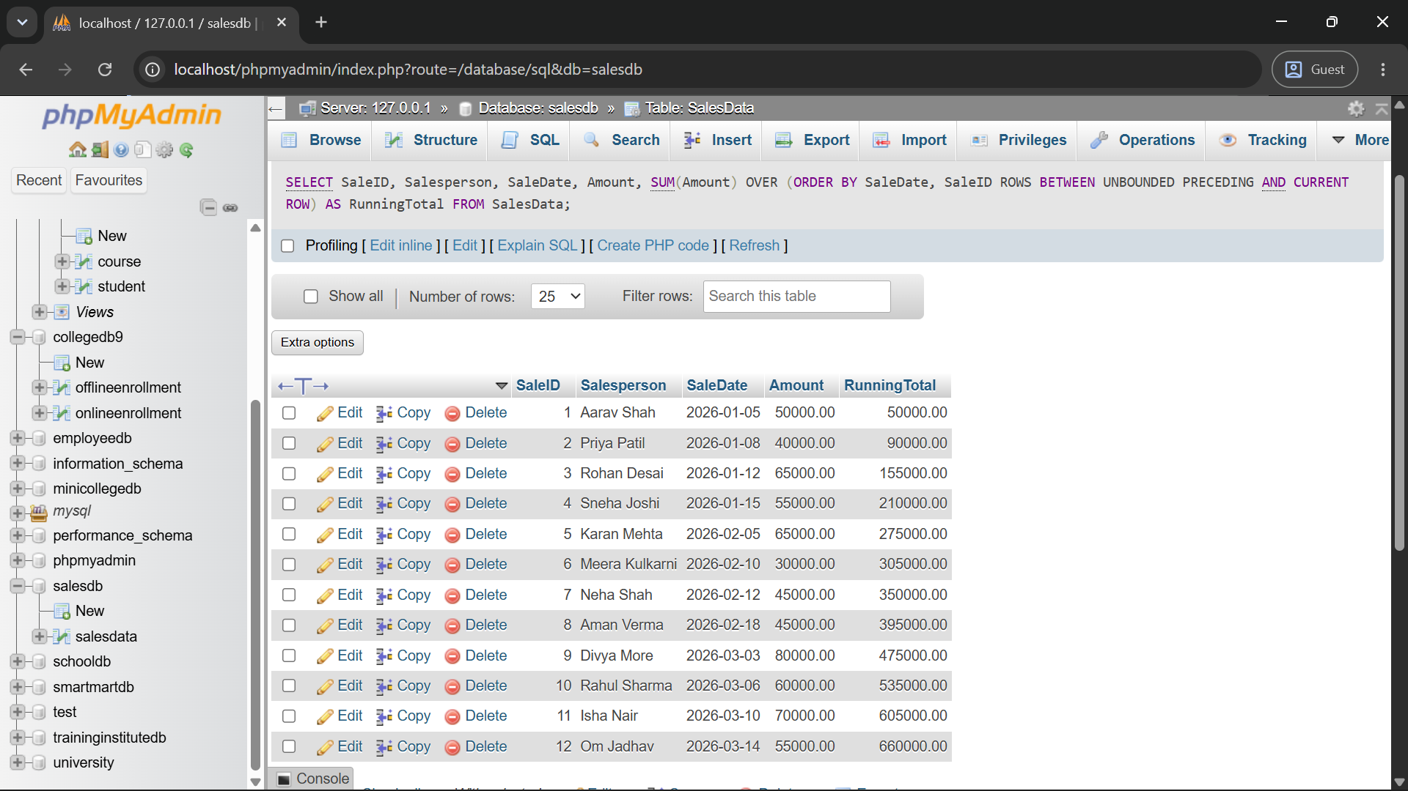
Q6) Write a MySQL query to display the highest-performing salesperson from each department.
The query should:
Requirement
Use ROW_NUMBER()
Partition records by department
Arrange sale amounts in descending order
Use a subquery
Display only the first-ranked salesperson from every department
Query:
SELECT Salesperson, Department, Amount
FROM (
SELECT
Salesperson,
Department,
Amount,
ROW_NUMBER() OVER (PARTITION BY Department ORDER BY Amount DESC) AS DeptRowNumber
FROM SalesData
) AS DepartmentSales
WHERE DeptRowNumber = 1;
